ASSIGNMENT

1. Create the project for any web application example using agile methodology (SCRUM TEMPLATE).

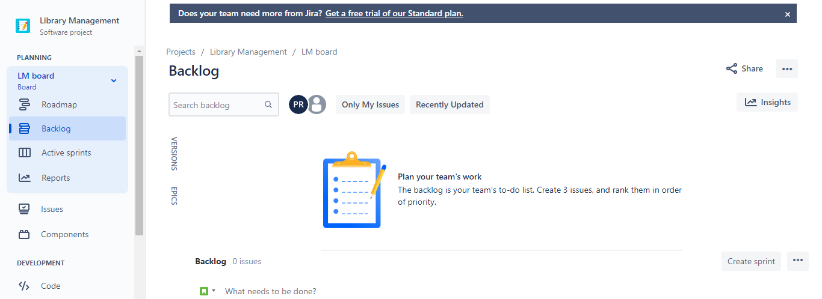

1. (6 ISSUES)>>>> 4 STORY , 1 TASK, BUG

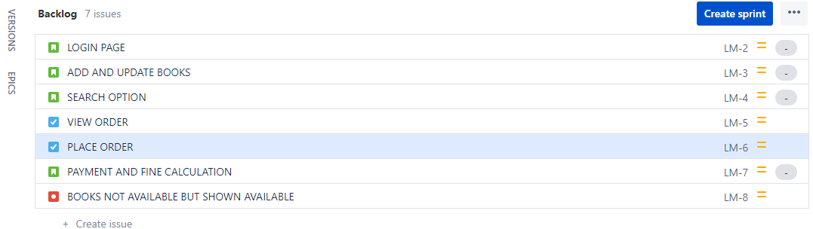

1. Create components

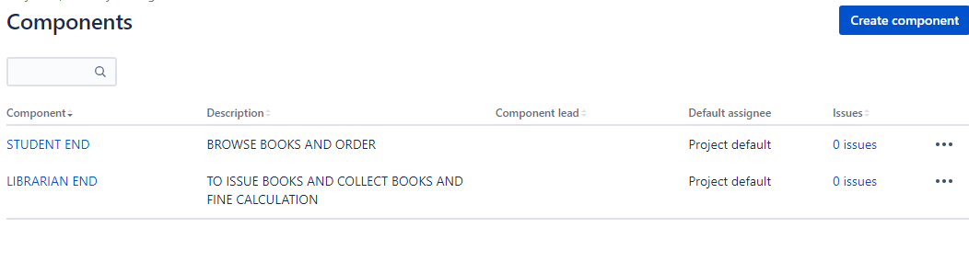

1. Plan the version with release dates

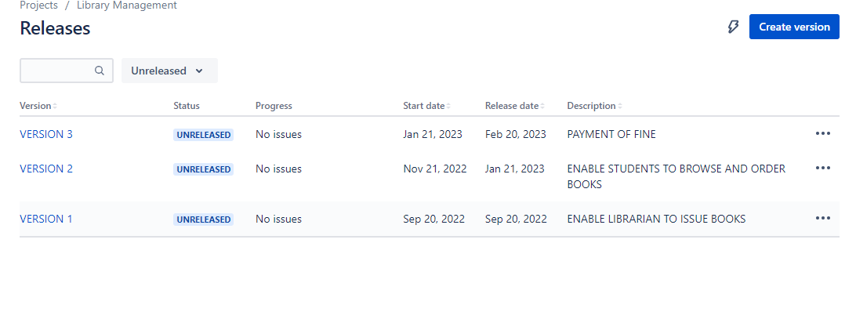

1. Create different types of issues in the backlog.

Epic –provide epic link also Story. Initialize story point, Associate with Version, component .Divide into sub-tasks .Give estimate time .Give time log work and comment it as well. Clone the story task and bug -Link with issues story and View workflows also.

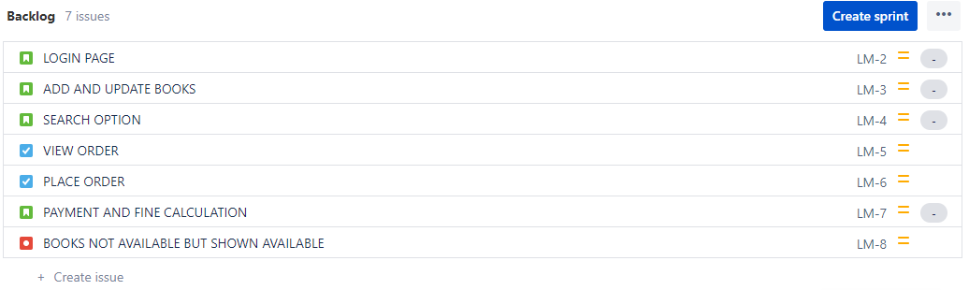

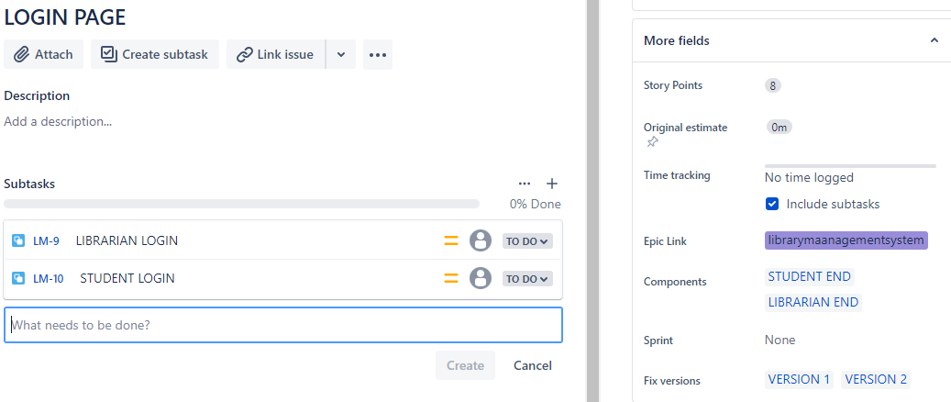

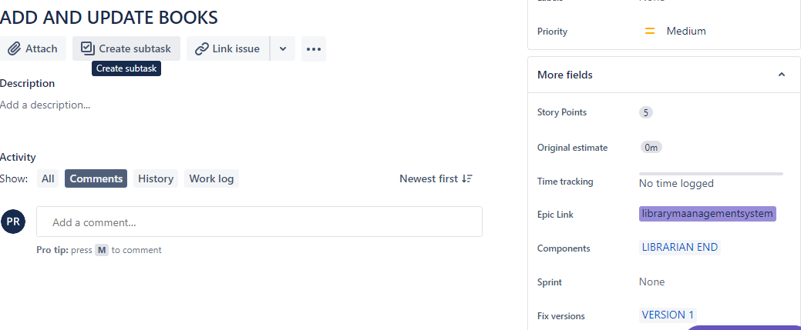

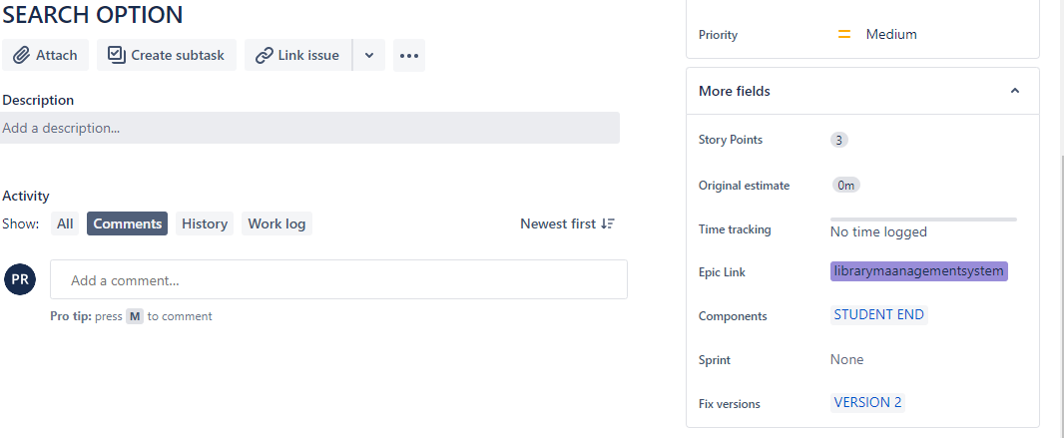

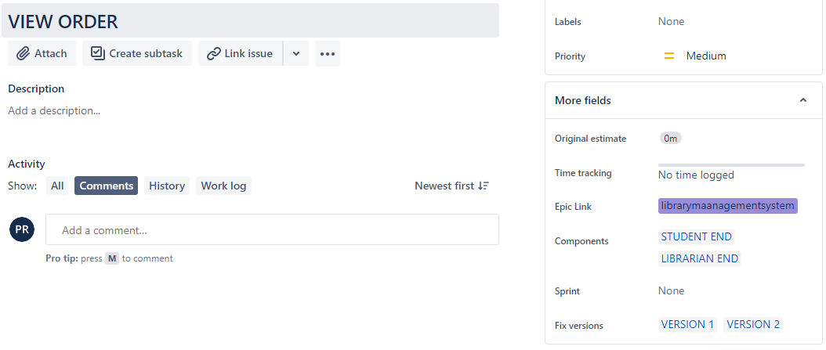

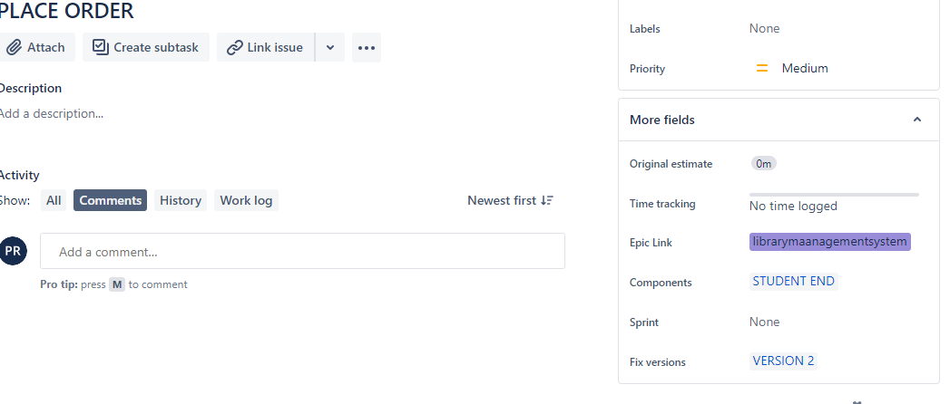

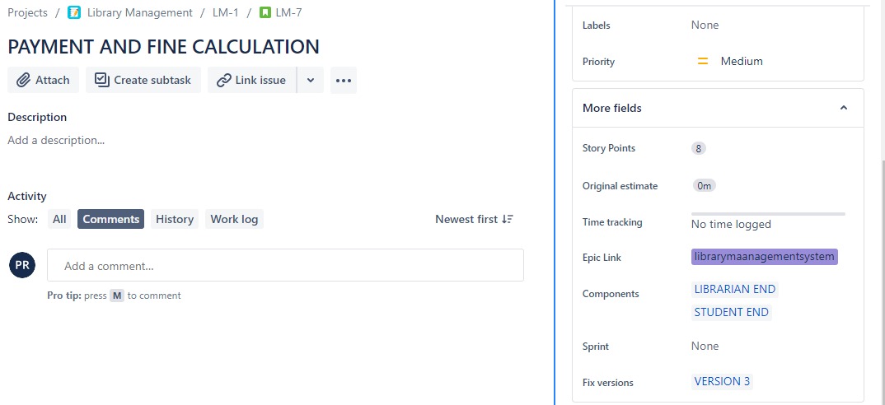

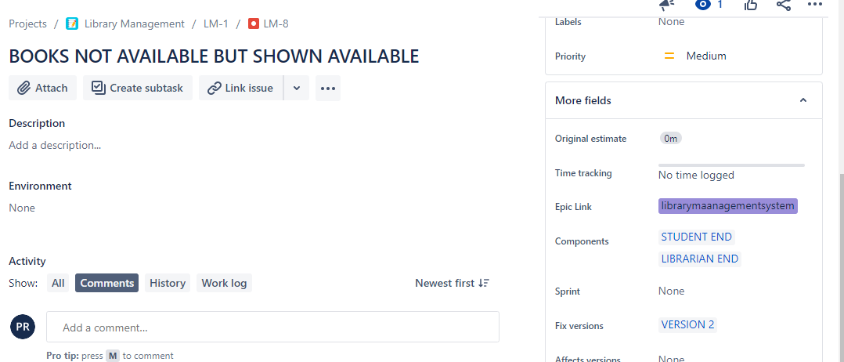

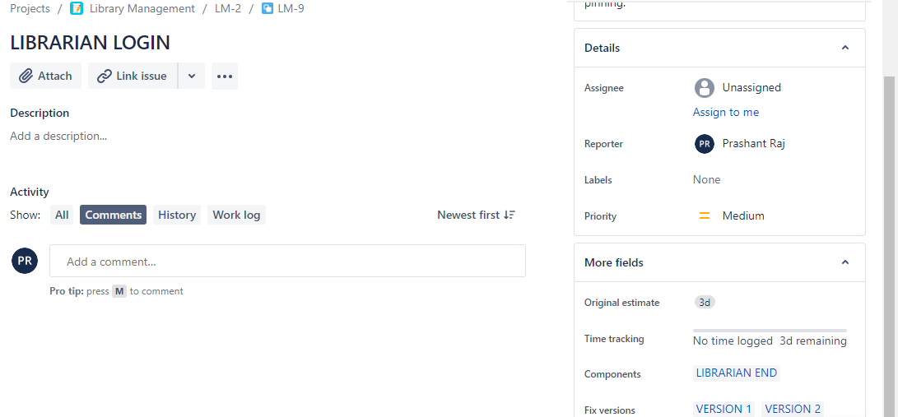

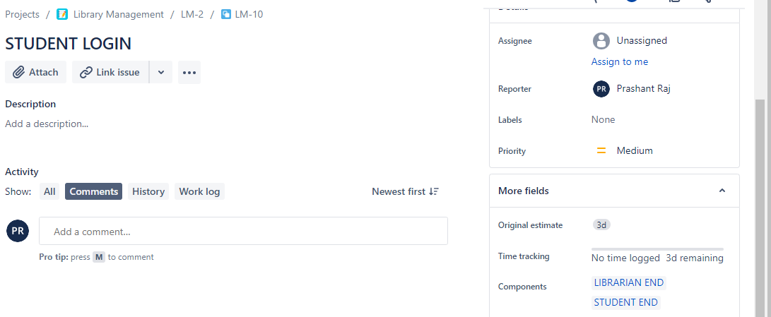

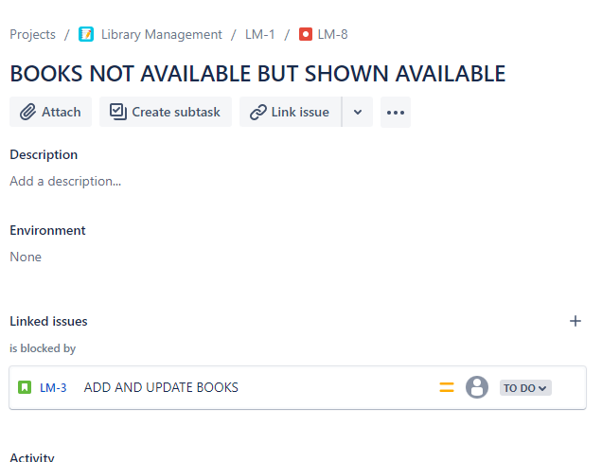

1. Create sprint backlog, start sprint and complete sprint

